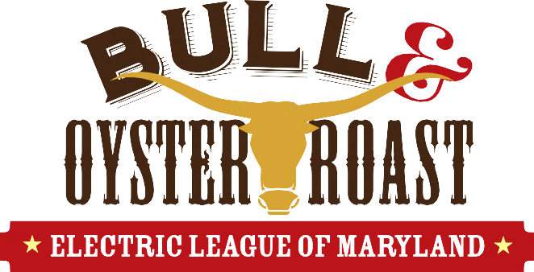

Wear your favorite football garb; we’ll have screens for watching Football!
SUNDAY, OCTOBER 8, 2023
1:00 p.m. - 5:00 p.m. (Food to be served at 1:30 p.m.)

Rosedale Gardens (Parking available across the street, too!)
8037 Philadelphia Road, Rosedale, MD 21237 Enjoy a live DJ, raffles, and good food!
Menu Includes:
Shrimp Oysters Baked Ziti Fried Chicken, Other Sides
Top Round of Beef Oyster Stew Swedish Meatballs Salads, Coleslaw, Green Beans
Pit-style Ham MD Crab Soup Italian Sausage Desserts
Sodas, Juices, Iced and Hot Tea, Coffee, Lemonade, and Draft Beer
- - - - - - - - - - - - - - - - - - - - - - - - - - - - - - - - - - - - - - - - - - - - - - - - - - - - - - - - - - - - - - - - - - - - - - - - - - - - - - - -
Tickets are $50 each (Tables of 10 available). Buy a Table of 10 and get five (5) discount coupons worth $25 each for future ELM Seminars (coupons distributed when you receive your tickets). Tickets sold on a first-come, first-serve basis. To reserve your seat(s), please complete this form and remit payment to: The Electric League of Maryland, P. O. Box 4, Fork, MD 21051. Call Pete Elmo at 443-271-3892 if you have questions.

YOUR NAME: ________________________________________ COMPANY NAME: ______________________________ CELL NUMBER: _______________

E-MAIL ADDRESS: ____________________________________ NUMBBER OF TICKETS ______ x $50 = $ ____________ (Send Check to Address Above)

